**DAY 1 - WELCOME TO BAKU. ARRIVAL**

* Arrival at Airport
* Transfer from Airport to Hotel

**DAY 2 - CITY TOUR**

* Breakfast in Hotel
* **LUNCH AT INDIAN RESTAURANT**
* 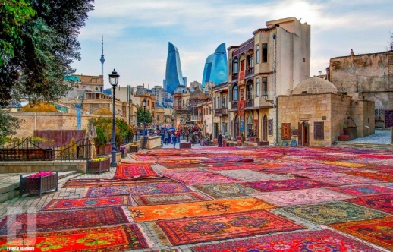Our tour program starts with **Old City**or Icheri Sheher is the historical core of [Baku](https://en.wikipedia.org/wiki/Baku), the capital of [Azerbaijan](https://en.wikipedia.org/wiki/Azerbaijan). The Old City is the most ancient part of Baku, which is surrounded by walls were well protected. In 2007, the Old City had a population of about 3000 people. In December 2000, the Old City of Baku, including the [Palace of the Shirvanshahs](https://en.wikipedia.org/wiki/Palace_of_the_Shirvanshahs)’ and [Maiden Tower](https://en.wikipedia.org/wiki/Maiden_Tower_(Baku)) ( Giz Galasi ), became the first location in [Azerbaijan](https://en.wikipedia.org/wiki/Republic_of_Azerbaijan) to be classified as a [World Heritage Site](https://en.wikipedia.org/wiki/World_Heritage_Site) by [UNESCO](https://en.wikipedia.org/wiki/UNESCO). (walking tour)
* 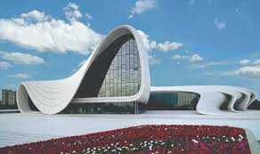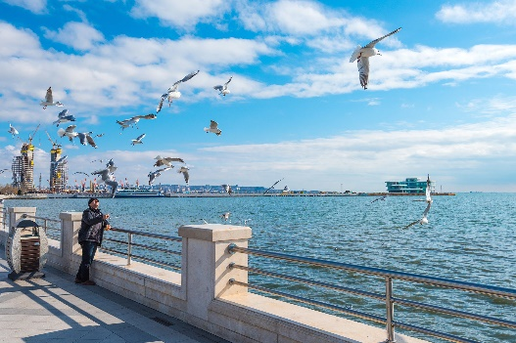Tour continues with the visit to the charming example of modern architecture - The **Heydar Aliyev Center** – a 57,500 m2 building complex in Baku, Azerbaijan designed by Iraqi-British architect Zaha Hadid and noted for its distinctive architecture and flowing, curved style that eschews sharp angles. The center is named after Heydar Aliyev, the first secretary of Soviet Azerbaijan from 1969 to 1982, and president of Azerbaijan Republic from October 1993 to October 2003. **(Photo shoot outside)**
* Walking through **Baku Boulevard** which stretches along a south-facing bay on the Caspian Sea. It traditionally starts at Freedom Square continuing west to the Old City and beyond. Since 2012, the Yeni Bulvar (New Boulevard) has virtually doubled the length to 3.75 km.
* **DINNER AT INDIAN RESTAURANT**
* **Back to Hotel**

**DAY 3 – FLAME & GOBUSTAN TOUR**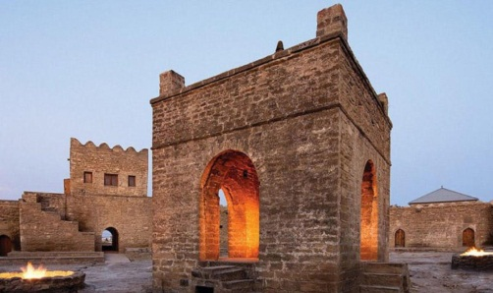

* Breakfast in Hotel
* Tour starts with **Ateshgah** (Fire Worshippers Temple) Based on Persian and Indian inscriptions, the temple was used as a [Hindu](https://en.wikipedia.org/wiki/Hindu) and [Zoroastrian](https://en.wikipedia.org/wiki/Zoroastrianism) place of worship. “Atash» is the Persian word for fire. The pentagonal complex , which has a courtyard surrounded by cells for monks and a tetra pillar-altar in the middle, was built during the 17th and 18th centuries.
* 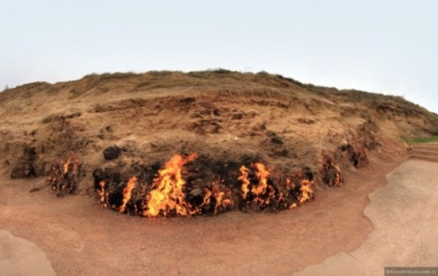Trip to “**Fire Mountain** “-“Yanardag” –a mountain on Absheron peninsula , 25 km from north of Baku.Literally, word “Yanardag” means “Blazing mountain”. Blazing bodies of flame dance on stones and floor. Yanar dag is a natural gas fire which blazes continuously on a hillside on the Absheron Peninsula on the Caspian Sea near Baku, the capital of Azerbaijan, which itself is known as the “land of fire.”
* **LUNCH AT INDIAN RESTAURANT**
* 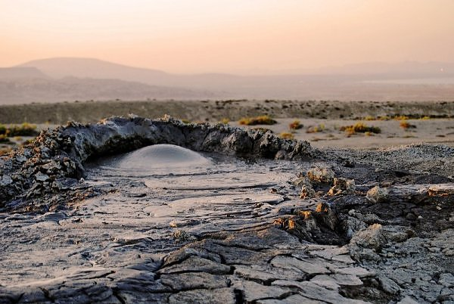Tour starts with **Qobustan** which is best known for being the home to the famous rock petroglyphs .The area has been settled since the 8th millennium BC. It is known for hosting thousands of rock engravings spread over 100 square km depicting hunting scenes, people, ships, constellations and animals. Its oldest petroglyphs date from the 12th century BC. In 2007, UNESCO included the ‘Gobustan Rock Art Cultural Landscape’ in the World Heritage list.
* Visit to **Mud Volcanoes**
* **DINNER AT INDIAN RESTAURANT**
* **Back to Hotel**

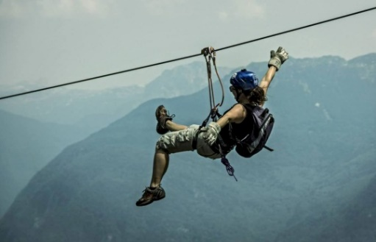

**DAY 4 - SHAHDAGH TOUR**

* Breakfast in Hotel
* Check out from Baku Hotel
* Assembly at hotel lobby. Departure to **SHAHDAGH (3 hours)**
* **LUNCH AT LOCAL RESTAURANT**
* 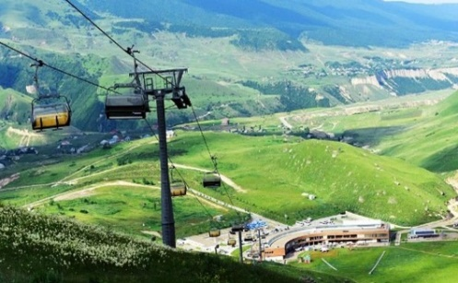Start to use Shahdag activities. **The Shahdag Mountain Resort Complex** was open to the public in 2012. It is located in the [Azerbaijan](https://en.wikipedia.org/wiki/Azerbaijan)'s [Greater Caucasus](https://en.wikipedia.org/wiki/Greater_Caucasus) range, the site is located near [Shahdag National Park](https://en.wikipedia.org/wiki/Shahdag_National_Park" \o "Shahdag National Park), which is known for having an intact ecological system and an untouched flora and fauna. It is the first and largest [ski resort](https://en.wikipedia.org/wiki/Ski_resort) in [Azerbaijan](https://en.wikipedia.org/wiki/Azerbaijan). Plans for the project include 4-5 star hotels, golf-clubs, 160-180 cottages and other objects in the complex. The winter season in Shahdag begins in the second half of December and finishes at the beginning of April, depending on snow conditions

[**https://www.shahdag.az/en/sports-activities**](https://www.shahdag.az/en/sports-activities)

* **DINNER AT LOCAL RESTAURANT**
* **Overnight stay at Shahdag Hotel**

**DAY 5 - GUBA TOUR**

* Breakfast in Hotel
* Departure to Guba
* 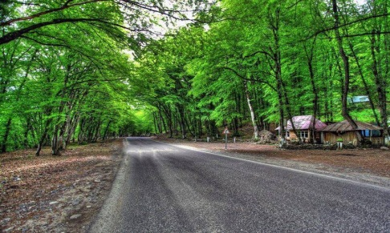**LUNCH AT LOCAL RESTAURANT**
* Arrival. **Guba City tour,** visit to oldest parts of the city, Old Mosques, hamams etc. , the bazaar of the city. We will also visit the local Carpet Shop where they make handmade carpets.   
  Quba tours will open up one of the most beautiful cities and the carpet weaving center of Azerbaijan. Here you will enjoy not only authentic Quba carpets but also lots of historical sights: old mosques, the Palace (House) of the Quba Khan, medieval baths and a fortress. The tourists usually choose for their rest **Gyachresh** area where you can relax in the shady woods
* Back to Baku
* **DINNER AT INDIAN RESTAURANT**
* **Back to Hotel**

**DAY 6 – GABALA TOUR**

* Breakfast in Hotel
* 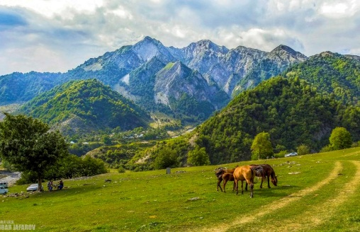Proceed to Departure to **Gabala** in the north-west of Azerbaijan The distance up to Baku 340 km (5 hours)
* Tour In Gabala
* **LUNCH AT INDIAN RESTAURANT**
* 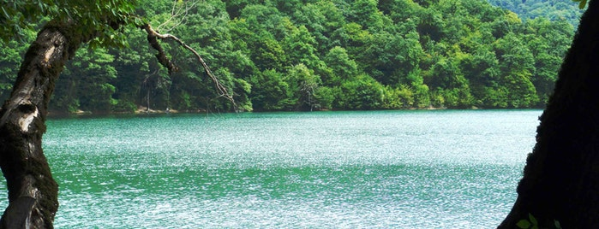Excursion in: Tufandaq” Winter-Summer Tourism Complexoffers cable car rides at any time of the year, skiing on the ski tracks of different difficulty level, ski training and ski school, catering service (cafe and restaurants), entertainment centers for kids, hotel and other services.
* Nohur Lake-It is located in Qabala, another region of Azerbaijan that one passes when travelling to Sheki. Lake is not on the way but if you go a bit deeper towards the mountains this beautiful view opens up in front of you.
* Back to Baku
* **DINNER AT INDIAN RESTAURANT**
* **Back to Hotel**

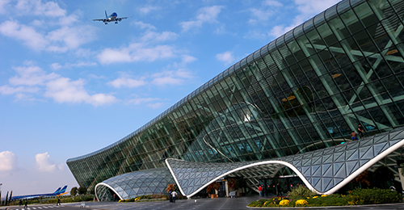

**DAY 7 - DEPARTURE**

* Breakfast in Hotel
* Departure to Airport for return flight

**Land Package - 325USD PER/PERSON FOR 19 ADULTS**

**Child (0-5 y.o.) – free of charge excluding visa cost**

**Child (6-11 y.o) – 50% of charge**

**INCLUSIONS:**

* **6 NIGHTS**
* Sightseeing in districts **(Baku, Absheron, Gobsutan, Shahdag, Quba, Gabala)**
* English speaking guide
* Entrance fee for Flame temple, Fire mountain, Gobustan museum, Mud Volcano, Shahdag cable car, Gabala cable car
* 2 Bottles of water per person per day
* All transfers according to program including airport transfers: ISUZU
* Visa (standard)

**EXCLUSIONS:**

**»** Anything not mentioned in inclusions.

**»** Porter service.

**»** Hard drinks.

**»** Charges in hotels for additional services & penalties.

**»** Any additional persons joining the group at the destination or any of the services will need to pay

**NOTE:**

**»** The Hotel check-in time 15:00 PM and check-out time is 12:00 PM.

**»** In the restaurants duration for having meals is 1,5 Hours normal dinner and lunches

**»** Outside liquor is not allowed in the restaurants. Corkage charge is – 20-30 USD per bottle

**»** Meals should be eaten at the restaurant , we are not responsible for take aways. For cancellation or change for any restaurant information should be given 24 hours before for free cancellation.

**»** The vehicle will move accordingly to time schedule mentioned on program. All group should leave Hotel for dinners on given time in the program for starting tour in the morning and moving for dinners in the evenings.

**CANCELLATION POLICY:**

**»** 48 hours prior to arrival All services are refundable (except hotel it depends on hotel policy)

**»** After 48 hours prior to arrival 1st night services are non-refundable rest days services refundable (except hotel it depends on hotel policy)  
**»** Refundable services are : Entrance Tickets, Meals   
  
Note: If number of cancelled people affects on group price, we will recalculate the price. Rates are not available for Black out and Holiday dates