**DAY 1 - WELCOME TO BAKU. ARRIVAL**

* Arrival at Airport
* Transfer from Airport to Hotel

**DAY 2 – FLAME TOUR**

* 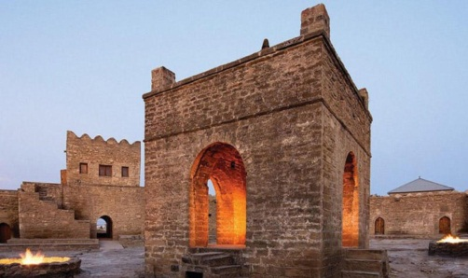Breakfast in Hotel
* Tour starts with **Ateshgah** (Fire Worshippers Temple) Based on Persian and Indian inscriptions, the temple was used as a [Hindu](https://en.wikipedia.org/wiki/Hindu) and [Zoroastrian](https://en.wikipedia.org/wiki/Zoroastrianism) place of worship. “Atash» is the Persian word for fire. The pentagonal complex , which has a courtyard surrounded by cells for monks and a tetra pillar-altar in the middle, was built during the 17th and 18th centuries.
* 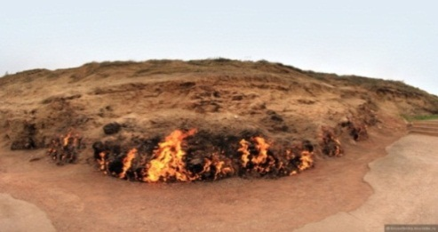Trip to “**Fire Mountain** “- “Yanardag” –a mountain on Absheron peninsula, 25 km from north of Baku. Literally, word “Yanardag” means “Blazing mountain”. Blazing bodies of flame dance on stones and floor. Yanar dag is a natural gas fire which blazes continuously on a hillside on the Absheron Peninsula on the Caspian Sea near Baku, the capital of Azerbaijan, which itself is known as the “land of fire.”
* 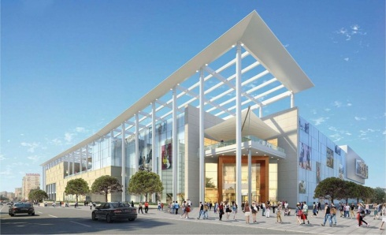**Ganjlik Mall:** - located in 10 minutes distance form city center with taxi. Ganjlik mall is the biggest Mall in Baku and contains over 80 stores, big bowling halls, the biggest movie halls, 3D cinema, Playground for children, Bravo supermarket, VIP restaurants, food courts
* **Back to Hotel**

**DAY 3 – GABALA TOUR**

* Breakfast in Hotel
* 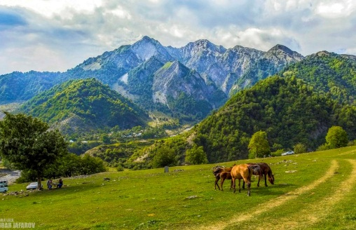Proceed to Departure to **Gabala** in the north-west of Azerbaijan The distance up to Baku 340 km (5 hours)
* Tour In Gabala
* 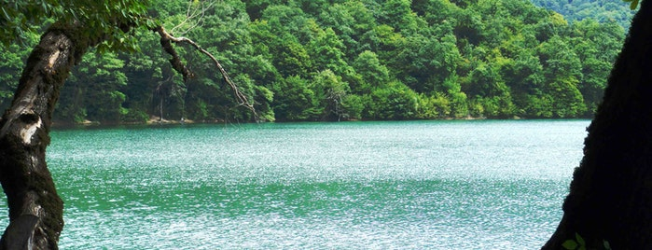Excursion in: Tufandaq” Winter-Summer Tourism Complexoffers cable car rides at any time of the year, skiing on the ski tracks of different difficulty level, ski training and ski school, catering service (cafe and restaurants), entertainment centers for kids, hotel and other services.
* Nohur Lake-It is located in Qabala, another region of Azerbaijan that one passes when travelling to Sheki. Lake is not on the way but if you go a bit deeper towards the mountains this beautiful view opens up in front of you.
* Back to Baku
* **Back to Hotel**

**DAY 4 – QOBUSTAN TOUR**

* Breakfast in Hotel
* 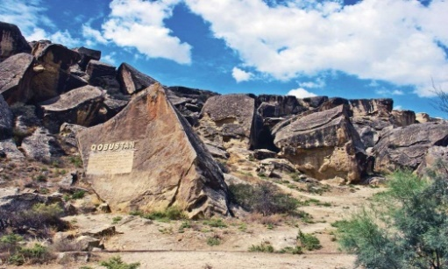Tour starts with **Qobustan** which is best known for being the home to the famous rock petroglyphs. The area has been settled since the 8th millennium BC. It is known for hosting thousands of rock engravings spread over 100 square km depicting hunting scenes, people, ships, constellations and animals. In 2007, UNESCO included the ‘Gobustan Rock Art Cultural Landscape’ in the World Heritage list.
* 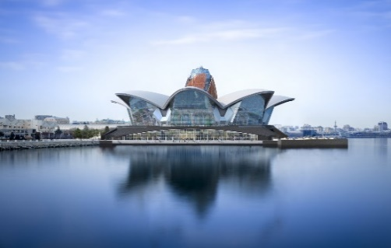Continue with **Deniz mall**: Located on land reclaimed from the Caspian Sea, Deniz Mall is a 120,000m² entertainment, leisure and dining destination over five floors. With its unique architectural concept, it will host brands such as Casa Culinary Art School of Azerbaijan, Beverly Hills and Chill Box, Big Chef, TGI Friday, Dine Hall, Kinderland for the first time in Azerbaijan, along with several well-known brands such as Starbucks, Nike, Swarovski, Pandora, Paul, Go Sport, Alma Store, LVIV Handmade Chocolate, Cinema Plus
* **Back to Hotel**

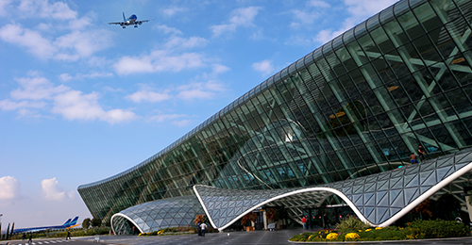

**DAY 5 - DEPARTURE**

* Breakfast in Hotel
* Departure to Airport for return flight

|  |  |  |
| --- | --- | --- |
| Atlas 4* | DBL | 243 |
| Atlas 4* | TRPL | 224 |
| Diamond 4* | DBL | 238 |
| Diamond 4* | TRPL | 224 |
| West Shine 4* | DBL | 255 |
| West Shine 4* | TRPL | 232 |
| City Park 4* | DBL | 291 |
| City Park 4* | TRPL | 275 |
| Sapphire Inn 4* | DBL | 355 |
| Sapphire Inn 4* | TRPL | 310 |
| Alba Hotel&SPA | DBL | 238 |
| Alba Hotel&SPA | TRPL | 228 |
| Holiday Inn 4* | DBL | 421 |
| Holiday Inn 4* | TRPL | 365 |
| Parkside 4* | DBL | 287 |
| Parkside 4* | TRPL | 275 |
| Austin 4* | DBL | 255 |
| Austin 4* | TRPL | 240 |
| Mercure 4* | DBL | 305 |
| Mercure 4* | TRPL | 292 |

**USD PER/PERSON FOR 8 ADULTS**

**Child (0-5 y.o.) – free of charge excluding visa cost**

**Child (6-11 y.o) – 50% of charge**

**30 sep – 04 oct**

**INCLUSIONS:**

* Accommodation in Hotel including breakfast (4 nights)
* Sightseeing in districts **(Baku, Absheron. Gobustan, Gabala)**
* English speaking guide
* Entrance fee for Flame temple, Fire mountain, Gobustan museum, Gabala cable car
* 2 Bottles of water per person per day
* All transfers according to program including airport transfers: Mercedes Sprinter
* Visa (standard)

**EXCLUSIONS:**

**»** Anything not mentioned in inclusions.

**»** Porter service.

**»** Hard drinks.

**»** Meals

**»** Charges in hotels for additional services & penalties.

**»** Any additional persons joining the group at the destination or any of the services will need to pay

**NOTE:**

**»** The Hotel check-in time 15:00 PM and check-out time is 12:00 PM.

**»** In the restaurants duration for having meals is 1,5 Hours normal dinner and lunches

**»** Outside liquor is not allowed in the restaurants. Corkage charge is – 20-30 USD per bottle

**»** Meals should be eaten at the restaurant , we are not responsible for take aways. For cancellation or change for any restaurant information should be given 24 hours before for free cancellation.

**»** The vehicle will move accordingly to time schedule mentioned on program. All group should leave Hotel for dinners on given time in the program for starting tour in the morning and moving for dinners in the evenings.

**CANCELLATION POLICY:**

**»** 48 hours prior to arrival All services are refundable (except hotel it depends on hotel policy)

**»** After 48 hours prior to arrival 1st night services are non-refundable rest days services refundable (except hotel it depends on hotel policy)  
**»** Refundable services are : Entrance Tickets, Meals   
  
Note: If number of cancelled people affects on group price, we will recalculate the price. Rates are not available for Black out and Holiday dates