overseastoursindore@gmail.com
- HOME
- REQUEST A DEMO
- WHY ONELOYALTY
- ABOUT US
- CONTACT US
- BLOG
- FOLLOW US

CHANNEL PARTNERS/B2B LOYALTY PROGRAMS
One Loyalty Channel Partner Loyalty Program helped Carl Zeiss retain and drive more sales from its channel partners.
A rewards program for channel partners /distributors is an essential tool to drive sales. Channel partners and distributors are usually have several competing products including your company's products.
So, a properly designed rewards program is a major game changer. Moreover unlike B2C incentive programs, B2B incentive programs has high potential since the loyalty earned is long term and can result in higher returns. According to market survey in B2B industry -
- 75% of managers and sales people said rewards program plays a major influence in willingness to sell or purchase product from a vendor.
- More than 80% felt that the ability to make money or get rewards from the supplier is a critical factor in decision making.

Beat the Competition
A B2B partner may have several vendors vying for their attention. A well designed rewards program can help you beat the competition for partner’s attention.

Segmentation and Targeted Communication
Partner reward data can act as bench mark for segmentation of partners into different tiers. Targeted communication based on this segmentation can be highly effective than one-size fits all communication.

Lower Cost and High Returns
The cost of managing and awarding B2B Loyalty programs is lower than B2C. The returns are lot higher.

Improved sales target Monitoring
Rewards can be set for specific sales targets and partners can be frequently alerted as to where they stand corresponding to these targets.

Analyze and Action
Analyze partner activity and get valuable analytics that can help you to effective action. Identify the best performers, weak markets, best or low selling products, etc., and take appropriate action.

Easier and Flexible Redemption
Provide various redemption options based on the diverse likes of your partners. Setup exclusive experience based rewards that can drive the desire and competition.

Why Channel Partner/B2B Loyalty
Channel Partner/B2B loyalty program can be seen as the key tool to generate higher value from your channel partner/B2B relationships. A B2B loyalty program supported by superior One Loyalty technology will give you an critical edge over competition. A portal where partners can view their points earned and benefits gained from the relationship is a major driver and motivating factor to sell your company’s products.
Moreover, with the data gathered from partner’s partnership rich analytics can be generated that can help management take right decisions and make continuous improvement to the Channel Patner/B2B Loyalty programs.

Benifits
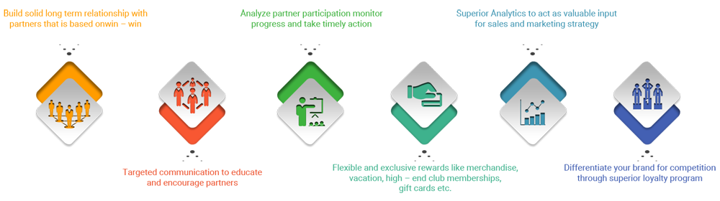

What Client’s Say
Carl Zeiss’s Channel Partner Loyalty programme is powered by One Loyalty Framework. It is a big success with our partners and the participation and feedback has been great. Carl Zeiss India is very happy with the Return on investment from our programme and the business intelligence gathered from the analytics is key for its continuous success.
Mr. Bhaskara Ranganatha
National Manager - IT
Carl Zeiss India
Team Arokia has swiftly guided us through the web development process and developed our website that is above excellence in its functionality and usability factor. The process re-engineering work, analysis and development of project really helped us to reduce the "time to market". They represent excellent value for money.
Arun Kumar Shetty
Divisional Manager
Carl Zeiss India

People are ExcitedHappy About One Loyalty
Some of our happy customers who were able to benefit from our solutions.

Keep in Touch
- info@oneloyalty.co

Socialize with Us

Newsletter
Keep in Touch & Receive Our Latest Updates.

- Home
- Sitemap
- Contact
Copyright © 2016 One Loyalty. All rights reserved.
Powered by

